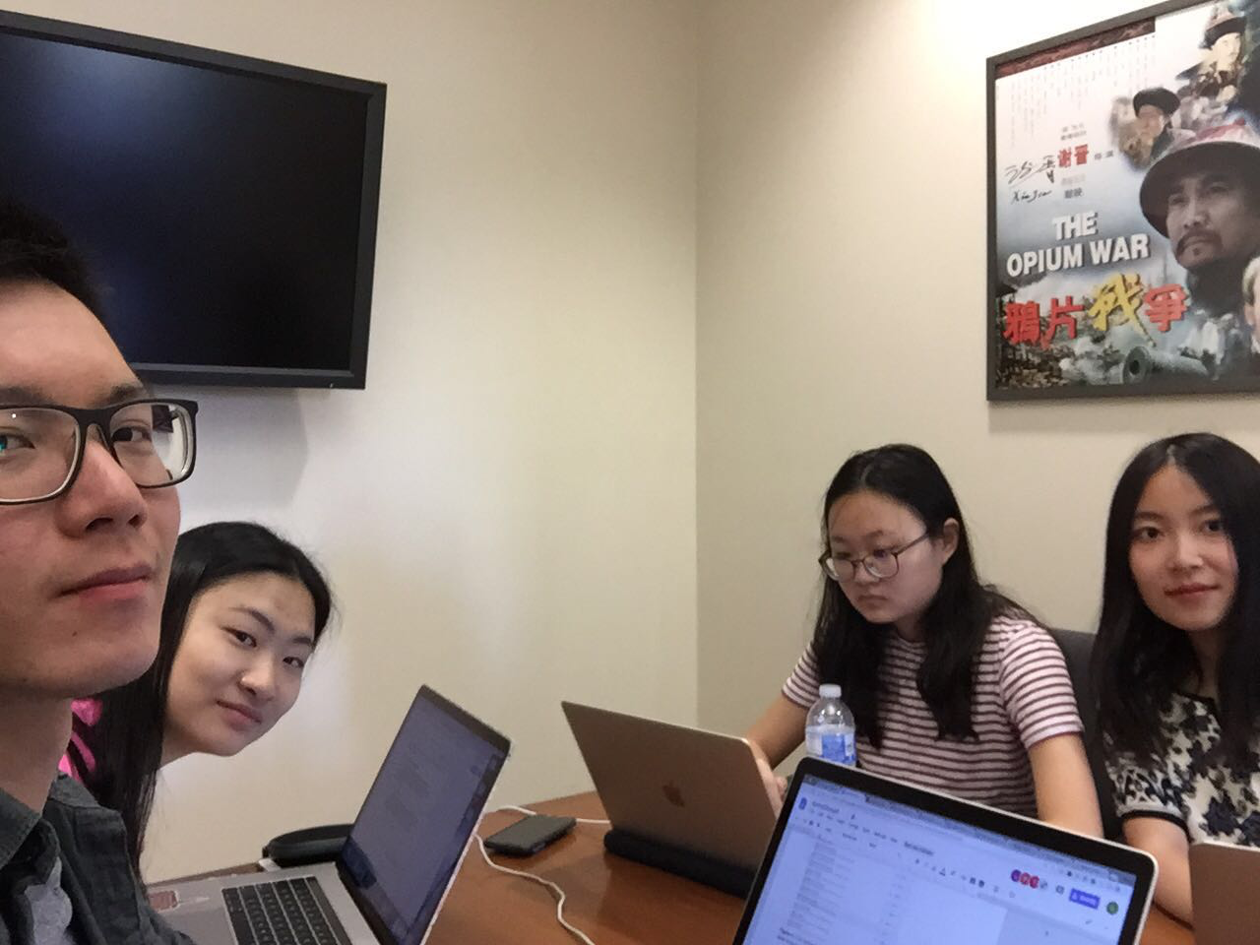

Allocated meeting time: April 14th, 2:00pm-3:00pm

Actual meeting time: April 14th, 2:00pm-3:00pm

Product owner: Professor Halfond, TAs, CPs

Scrum master: Gong Chen

Team members: Lingyi Li, Joann Lin, Peixuan Liu, Ryan To, Tuling Zhao

Scrum summary:

We were finishing up the sprint 2 process report.

1. What have you accomplished since the last meeting?
2. Are there any obstacles in the way of meeting your goal?
3. What will you accomplish before the next meeting?

Gong Chen:

1. Finishing the Section 3.1, 3.2, 4.1.4, 4.2 of the Sprint Document
2. None
3. Visiting office hour to ask for input on the document

Lingyi Li:

1. I finished section two of the sprint process report
2. None
3. I will write the sustainable pace section of the sprint process report

Joann Lin:

1. None
2. None
3. None

Absence Reason: Out of town for coachella

Peixuan Liu:

1. Run the software system and white-box testing. Make sure they generate expected results before the sprint review.
2. None
3. Finish the document

Ryan To:

1. None
2. None
3. None

Absence Reason: Out of town for Coachella

Tuling Zhao:

1. Worked on document
2. None
3. Will continue to work on document